Design Plan: Easytickets.com | Document Name: DFD | SWD/ Form No.7
Effective Date: Sept 10,2018 | Version: 1 | Page No:

DFD level 1:

Design Plan: Easytickets.com | Document Name: Flow chart | SWD/ Form No.7
Effective Date: Sept 10, 2018 | Version: 1 | Page No:1

Flow chart: Customer Log In
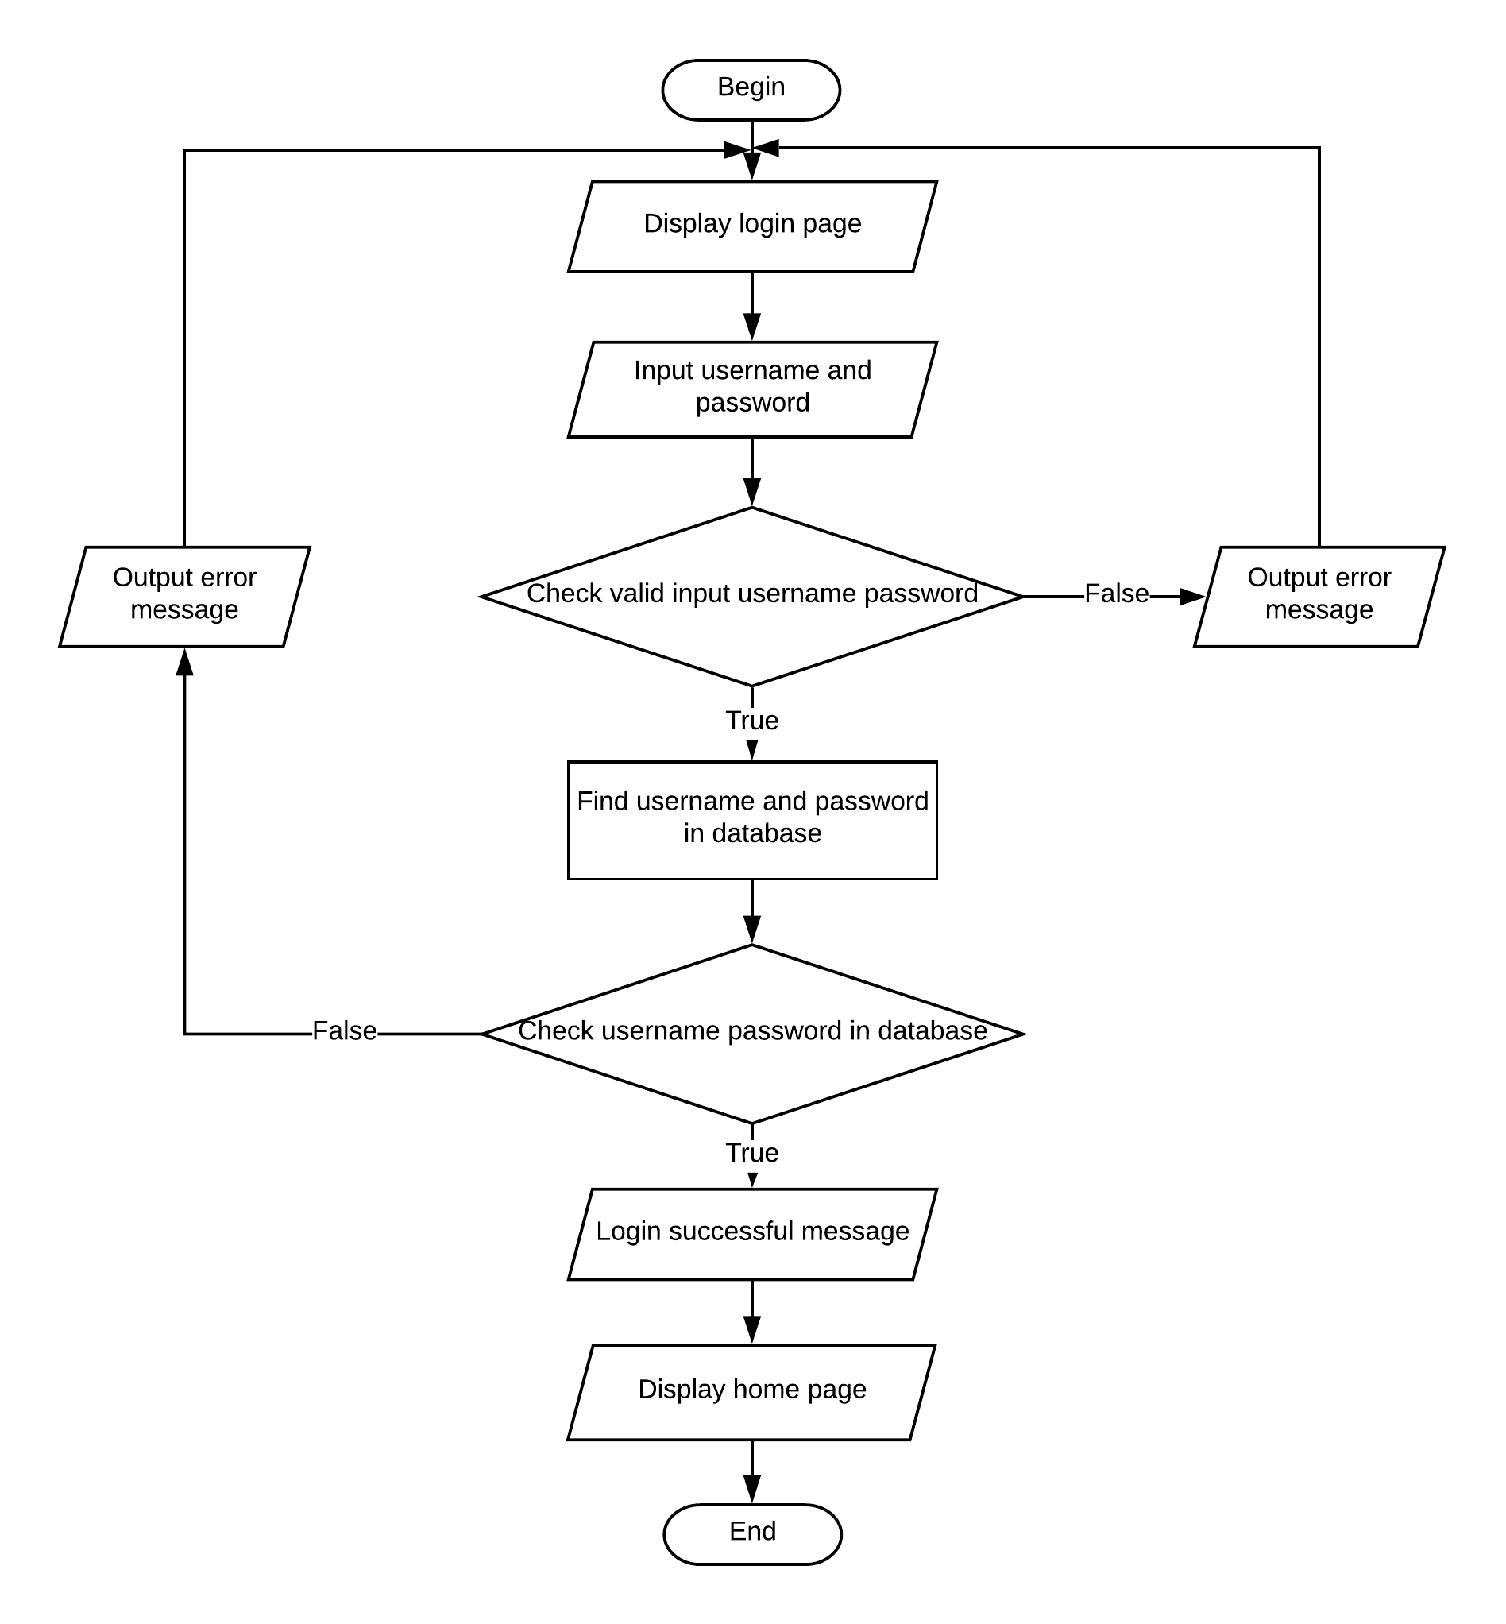

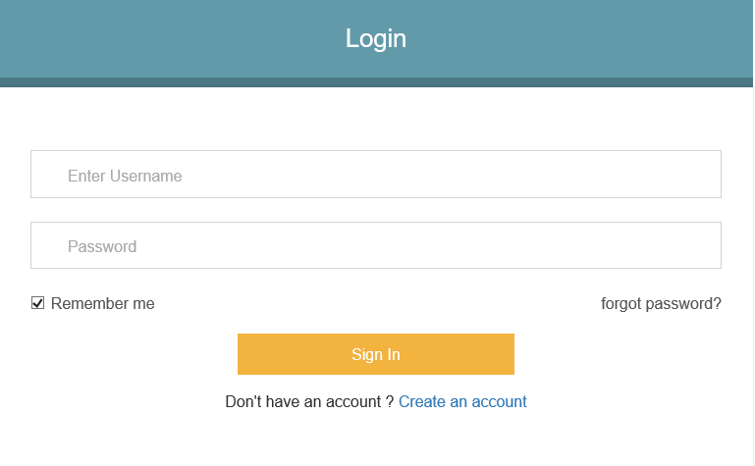

Design Plan: Easytickets.com | Document Name: Flow chart | SWD/ Form No.7
Effective Date: Sept 10, 2018 | Version: 1 | Page No:2

Flow chart: Customer Sign up
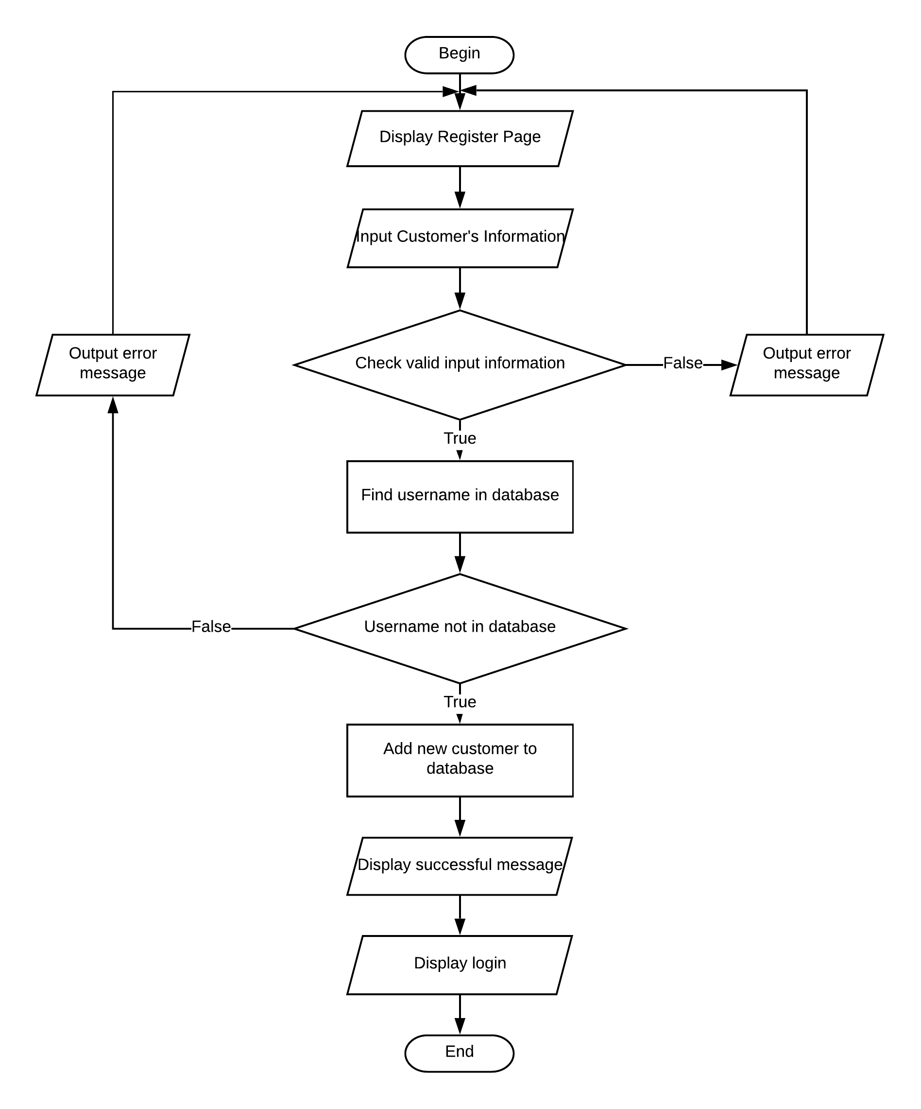
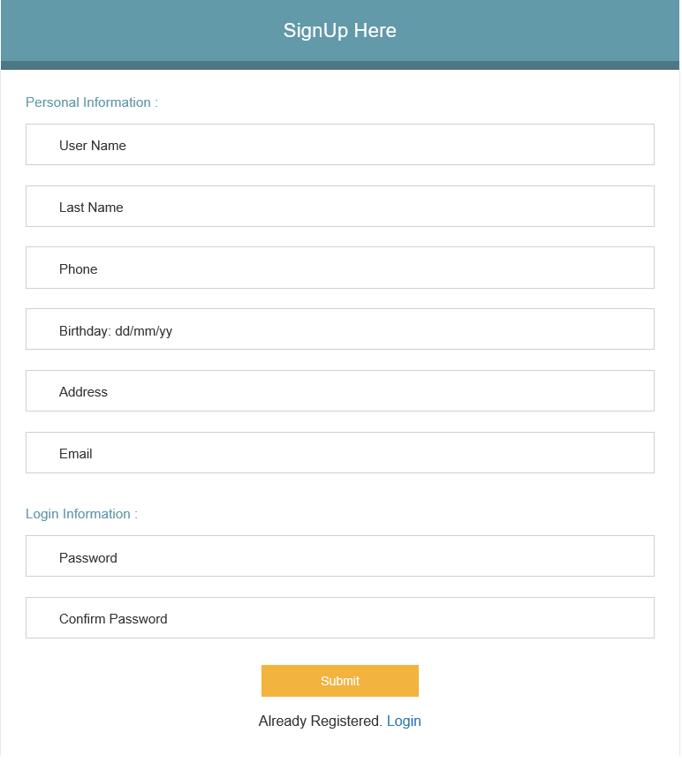

Design Plan: Easytickets.com | Document Name: Flow chart | SWD/ Form No.7
Effective Date: Sept 10, 2018 | Version: 1 | Page No:3

Flow chart: Customer Change Password
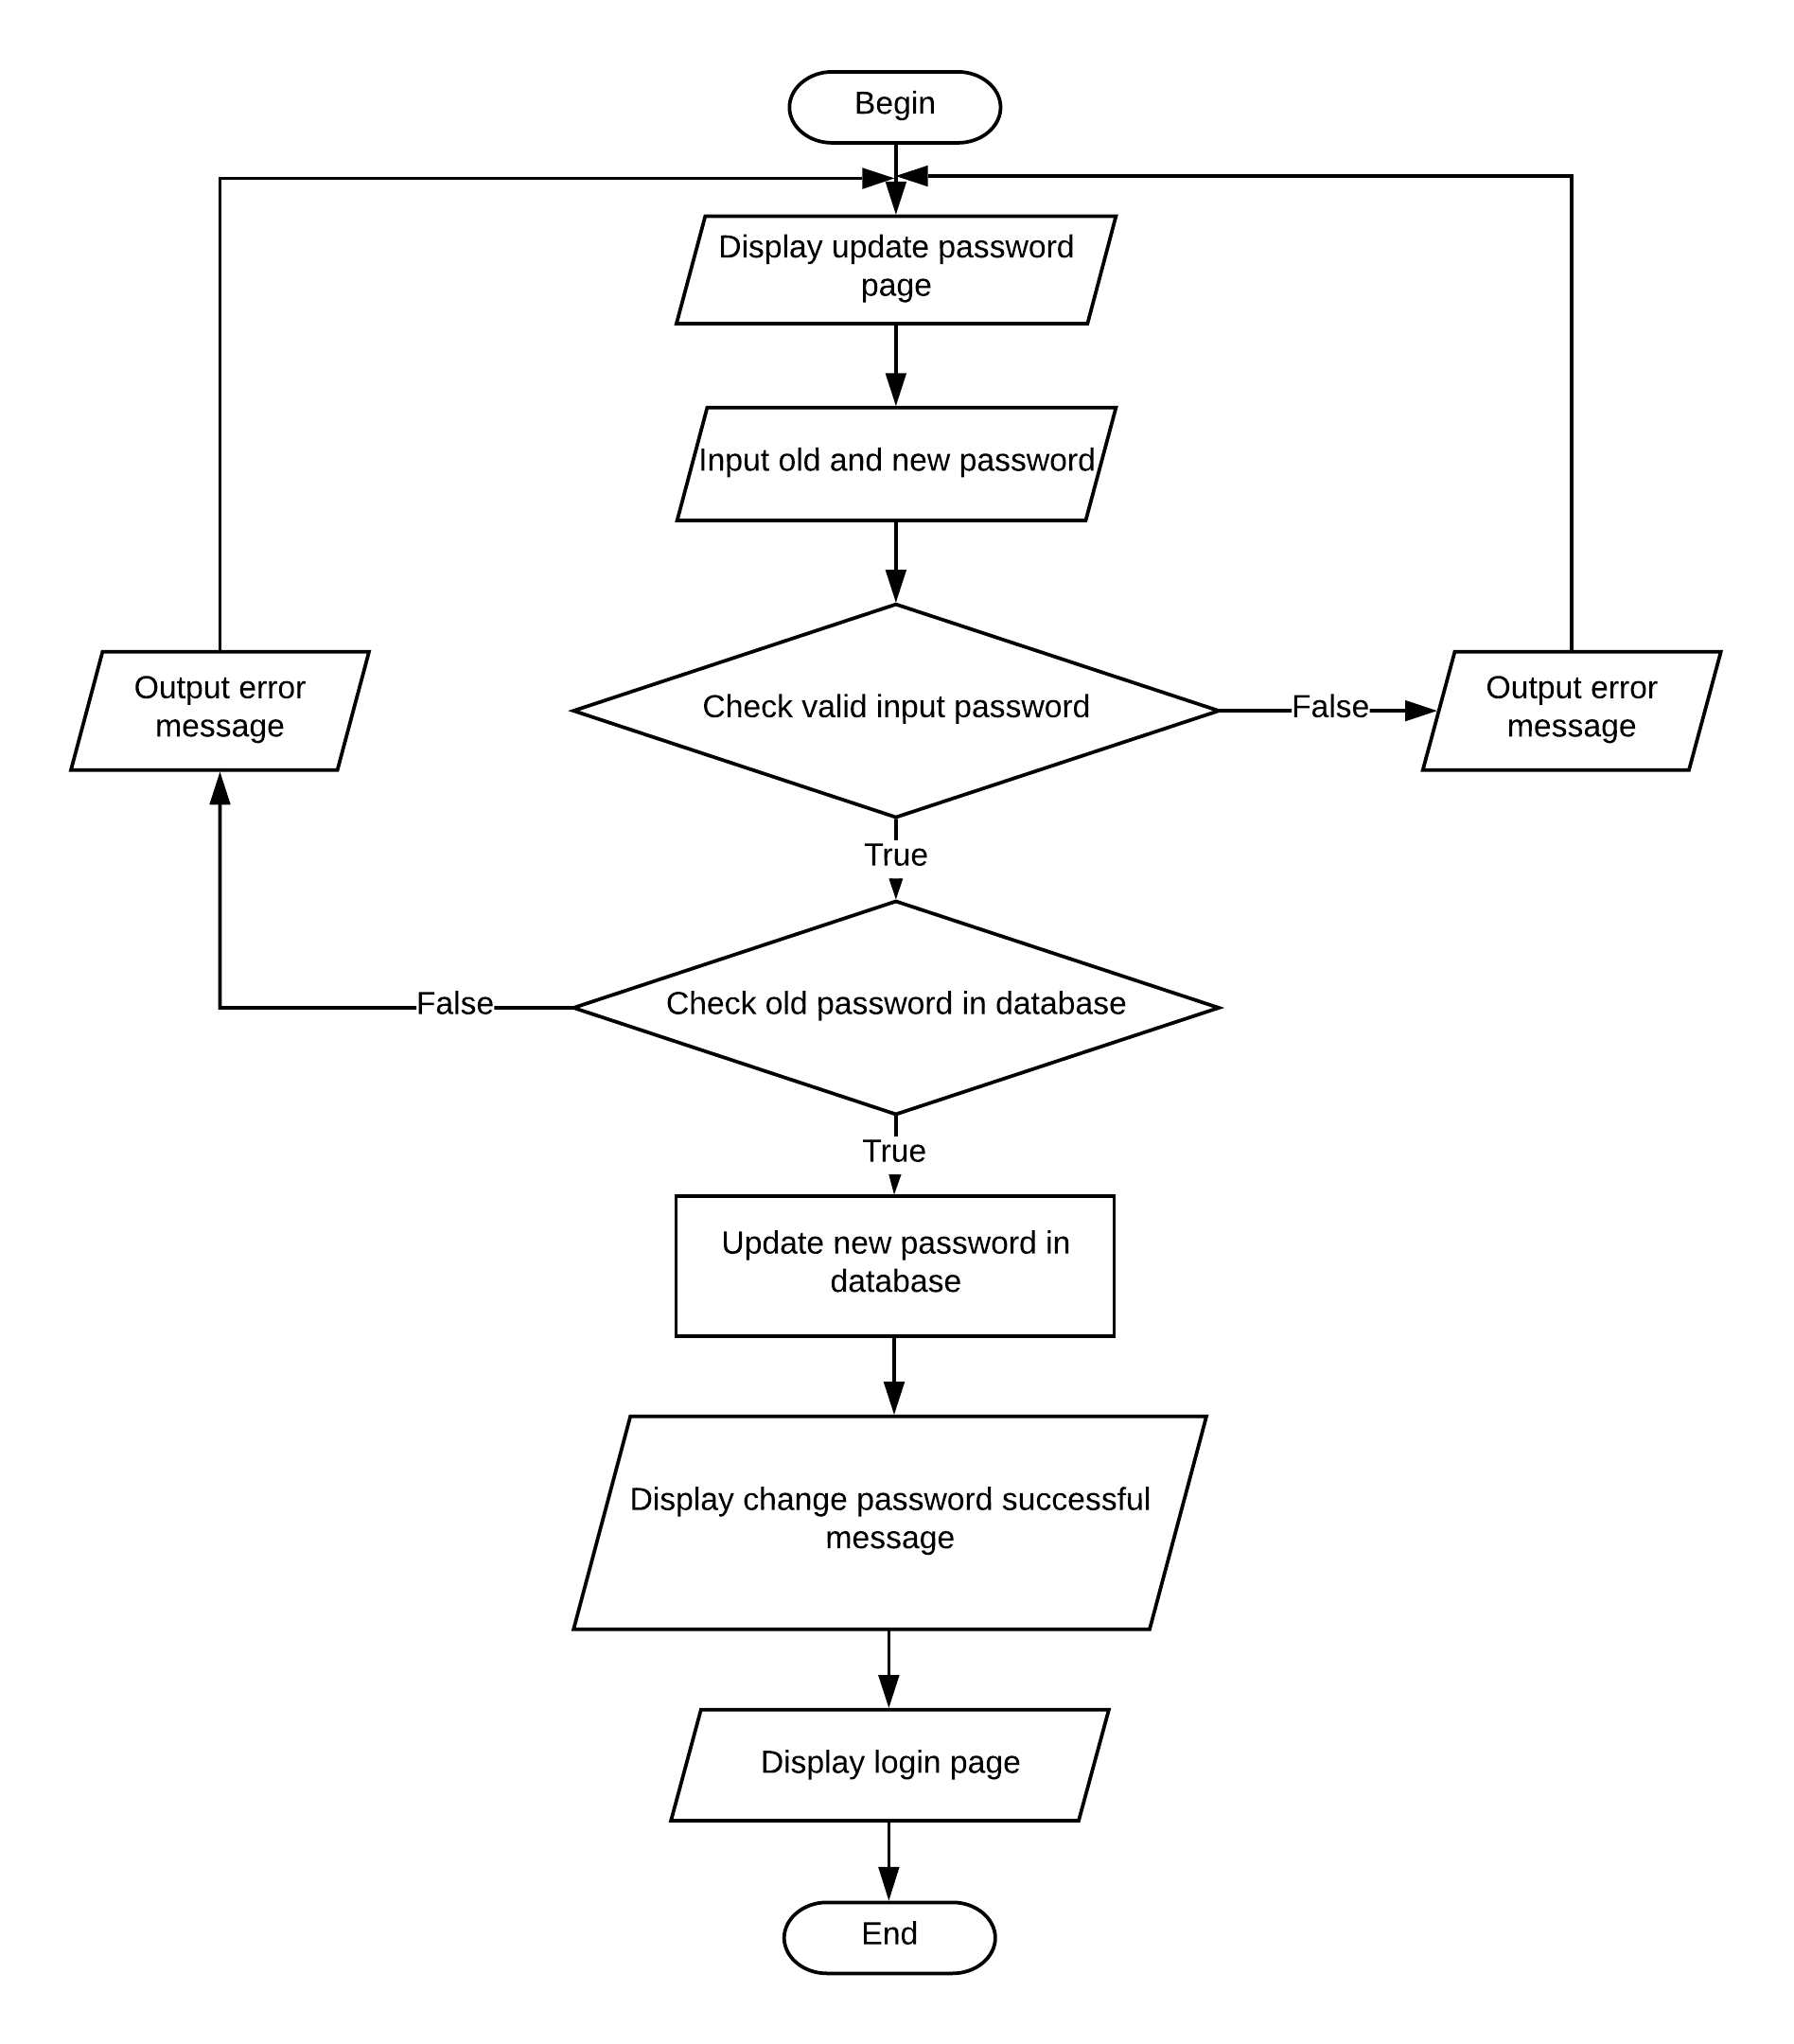
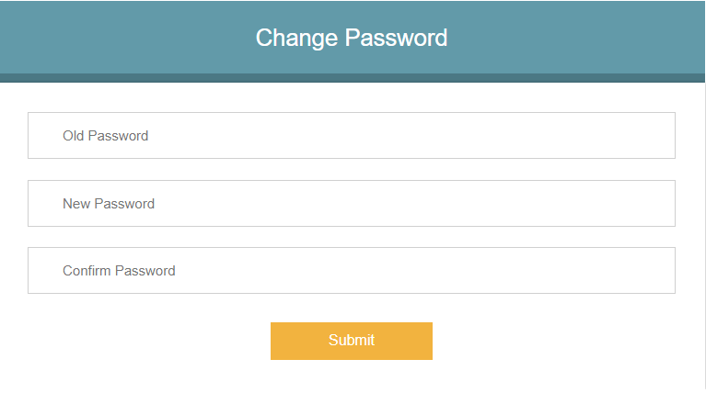

Design Plan: Easytickets.com | Document Name: Flow chart | SWD/ Form No.7
Effective Date: Sept 10, 2018 | Version: 1 | Page No:4

Flow chart: Change Information
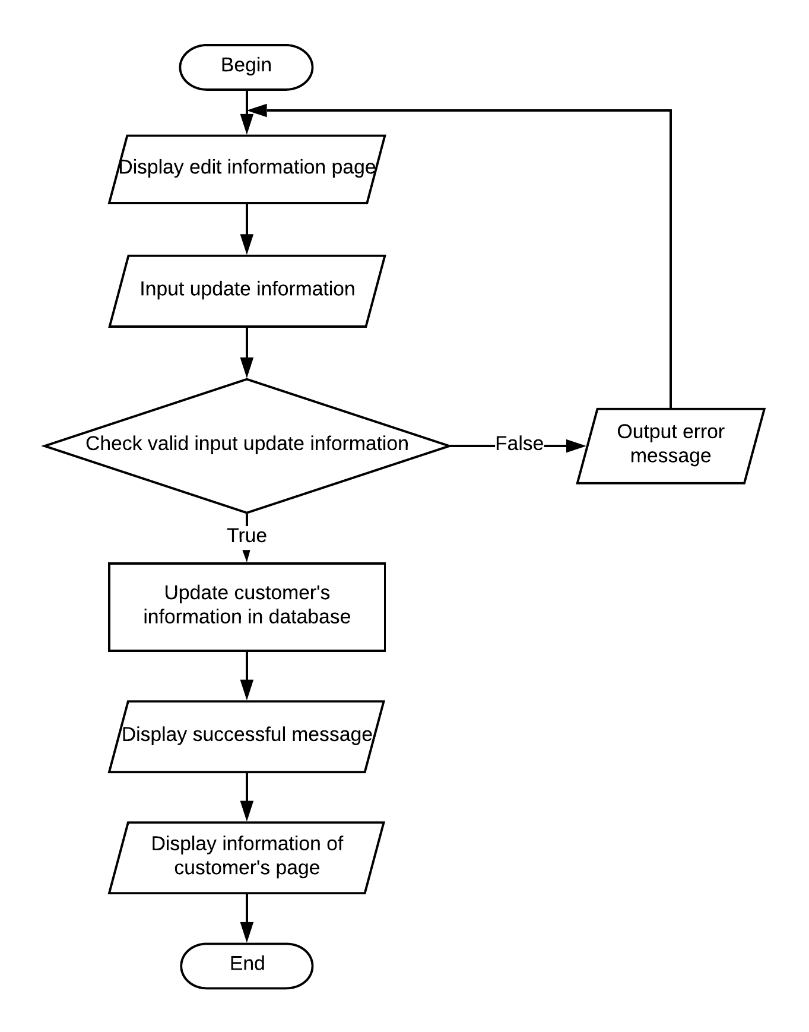

Design Plan: Easytickets.com | Document Name: Flow chart | SWD/ Form No.7
Effective Date: Sept 10, 2018 | Version: 1 | Page No:5

Flow chart: Reset Password

Design Plan: Easytickets.com | Document Name: Flow chart | SWD/ Form No.7
Effective Date: Sept 10, 2018 | Version: 1 | Page No:

